Lighting Column Datasheet for Flower Baskets

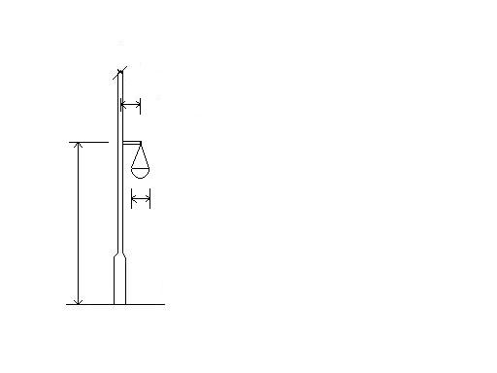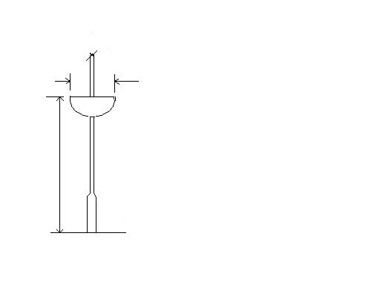
e
D
D
GL
GL
h
h
Hanging Baskets Clamped Baskets

Hanging Clamped
Number of Baskets at same height: Not Required

Basket Weight Each (watered) W kg:

Total Weight

Mounting Height h meters:

Diameter D meters:

Zero
Eccentricity e mm:

Orientation Under Column Bracket 0⁰

Right angles to Col Bkt. 90⁰ Not Required

Opposite Column Bracket 180⁰

Tick as appropriate for 1 & 2 baskets.

Note: If a second or third basket is of different dimensions or height, please provide the data for each additional basket below.

