Lighting Column Datasheet for Banners/Festive Motifs

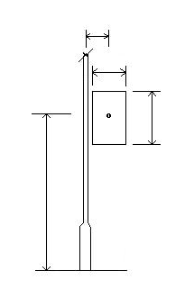
h
d
w
e
GL
Note: This data sheet should be used for signs, decorations and banners.
It will be assumed the sign is rigid unless additional information is provided. For example a banner supported along the top edge only, or three point support so that the outer lower corner is free.
There are also spring loaded sign supports for which full information will be necessary.
1st Sign 2nd Sign

Tick as appropriate.
Sign Shape Rectangular:

Circular:

Irregular (provide details separately);

Sign Weight W kg:

Mounting Height h meters:

OR; Clearance to Lowest Point meters:

Eccentricity (if central e = 0) e mm:

Sign Depth or Diameter d mm:

Sign Width if not Circular w mm:

Solidity % (solid = 100%) D mm:

If solidity is not known provide a sample, a photograph with scale or contact details of supplier.

Orientation of attached sign in relation to the lantern: Tick as appropriate.

Under Column Bracket 0⁰

Right angles to Col Bkt. 90⁰

Opposite Column Bracket 180⁰

Note: If there are two signs, please provide the data for both.
Additional Information:

